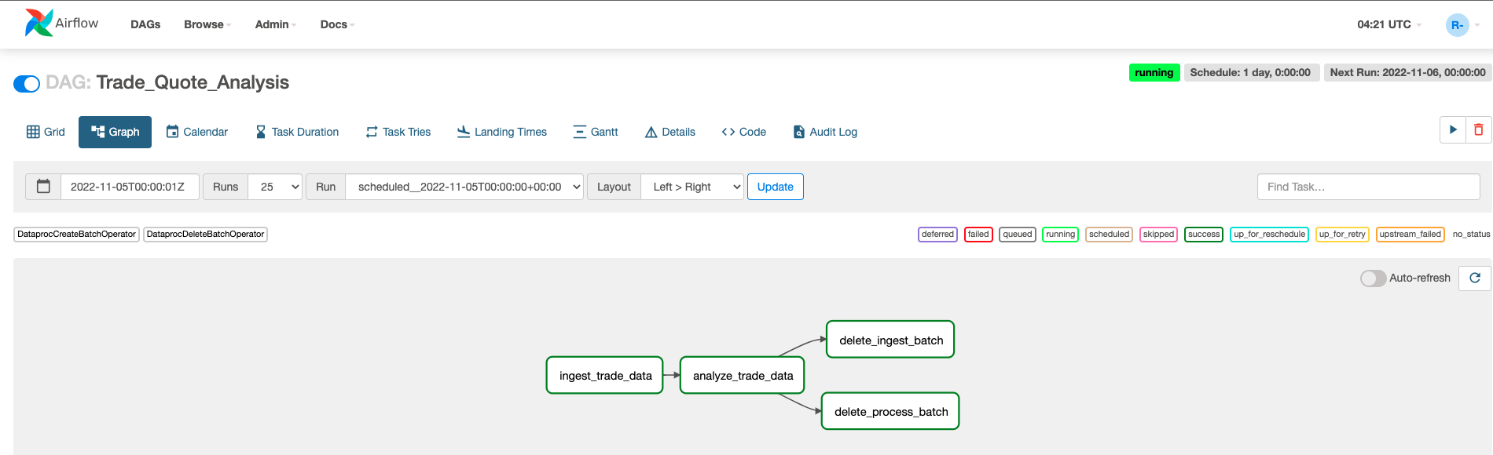

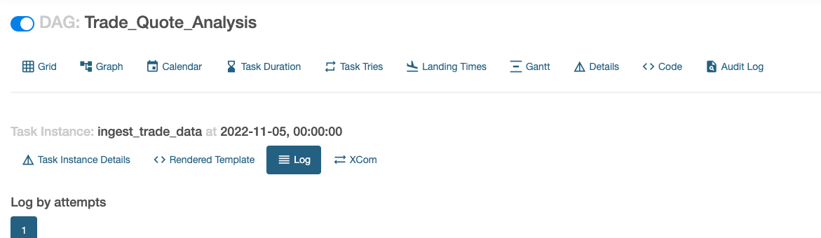

*** Reading remote log from gs://us-east1-spark-airflow-comp-9c560139-bucket/logs/dag_id=Trade_Quote_Analysis/run_id=scheduled__2022-11-05T00:00:00+00:00/task_id=ingest_trade_data/attempt=1.log.

[2022-11-06, 03:55:36 UTC] {taskinstance.py:1180} INFO - Dependencies all met for <TaskInstance: Trade_Quote_Analysis.ingest_trade_data scheduled__2022-11-05T00:00:00+00:00 [queued]>

[2022-11-06, 03:55:36 UTC] {taskinstance.py:1180} INFO - Dependencies all met for <TaskInstance: Trade_Quote_Analysis.ingest_trade_data scheduled__2022-11-05T00:00:00+00:00 [queued]>

[2022-11-06, 03:55:36 UTC] {taskinstance.py:1377} INFO -

--------------------------------------------------------------------------------

[2022-11-06, 03:55:36 UTC] {taskinstance.py:1378} INFO - Starting attempt 1 of 3

[2022-11-06, 03:55:36 UTC] {taskinstance.py:1379} INFO -

--------------------------------------------------------------------------------

[2022-11-06, 03:55:36 UTC] {taskinstance.py:1398} INFO - Executing <Task(DataprocCreateBatchOperator): ingest_trade_data> on 2022-11-05 00:00:00+00:00

[2022-11-06, 03:55:36 UTC] {standard_task_runner.py:52} INFO - Started process 2179 to run task

[2022-11-06, 03:55:36 UTC] {standard_task_runner.py:79} INFO - Running: ['airflow', 'tasks', 'run', 'Trade_Quote_Analysis', 'ingest_trade_data', 'scheduled__2022-11-05T00:00:00+00:00', '--job-id', '50', '--raw', '--subdir', 'DAGS_FOLDER/trade_analysis_pipeline.py', '--cfg-path', '/tmp/tmp5yd0s0z8', '--error-file', '/tmp/tmpj885cchz']

[2022-11-06, 03:55:36 UTC] {standard_task_runner.py:80} INFO - Job 50: Subtask ingest_trade_data

[2022-11-06, 03:55:37 UTC] {task_command.py:375} INFO - Running <TaskInstance: Trade_Quote_Analysis.ingest_trade_data scheduled__2022-11-05T00:00:00+00:00 [running]> on host airflow-worker-trp9b

[2022-11-06, 03:55:37 UTC] {taskinstance.py:1591} INFO - Exporting the following env vars:

AIRFLOW_CTX_DAG_OWNER=airflow

AIRFLOW_CTX_DAG_ID=Trade_Quote_Analysis

AIRFLOW_CTX_TASK_ID=ingest_trade_data

AIRFLOW_CTX_EXECUTION_DATE=2022-11-05T00:00:00+00:00

AIRFLOW_CTX_TRY_NUMBER=1

AIRFLOW_CTX_DAG_RUN_ID=scheduled__2022-11-05T00:00:00+00:00

[2022-11-06, 03:55:37 UTC] {base.py:68} INFO - Using connection ID 'google_cloud_default' for task execution.

[2022-11-06, 03:55:37 UTC] {dataproc.py:2022} INFO - Creating batch

[2022-11-06, 03:58:48 UTC] {taskinstance.py:1911} ERROR - Task failed with exception

Traceback (most recent call last):

File "/opt/python3.8/lib/python3.8/site-packages/airflow/providers/google/cloud/hooks/dataproc.py", line 246, in wait_for_operation

return operation.result(timeout=timeout)

File "/opt/python3.8/lib/python3.8/site-packages/google/api_core/future/polling.py", line 137, in result

raise self._exception

google.api_core.exceptions.Aborted: 409 Google Cloud Dataproc Agent reports job failure. If logs are available, they can be found at:

<https://console.cloud.google.com/dataproc/batches/us-east1/ingest-batch-create?project=my-project-367217>

gcloud dataproc batches wait 'ingest-batch-create' --region 'us-east1' --project my-project-367217'

<https://console.cloud.google.com/storage/browser/dataproc-staging-us-east1-665710256196-gtkvwse4/google-cloud-dataproc-metainfo/77dd9478-2848-4980-a371-622d8ec9982d/jobs/srvls-batch-e2f71042-8ef3-42bc-a60e-dad5fc7f905f/>

gs://dataproc-staging-us-east1-665710256196-gtkvwse4/google-cloud-dataproc-metainfo/77dd9478-2848-4980-a371-622d8ec9982d/jobs/srvls-batch-e2f71042-8ef3-42bc-a60e-dad5fc7f905f/driveroutput

During handling of the above exception, another exception occurred:

Traceback (most recent call last):

File "/opt/python3.8/lib/python3.8/site-packages/airflow/providers/google/cloud/operators/dataproc.py", line 2038, in execute

result = hook.wait_for_operation(timeout=self.timeout, operation=self.operation)

File "/opt/python3.8/lib/python3.8/site-packages/airflow/providers/google/cloud/hooks/dataproc.py", line 249, in wait_for_operation

raise AirflowException(error)

airflow.exceptions.AirflowException: 409 Google Cloud Dataproc Agent reports job failure. If logs are available, they can be found at:

[https://console.cloud.google.com/dataproc/batches/us-east1/ingest-batch-create?project= my-project-367217](https://console.cloud.google.com/dataproc/batches/us-east1/ingest-batch-create?project=splendid-planet-367217)

gcloud dataproc batches wait 'ingest-batch-create' --region 'us-east1' --project my-project-367217

<https://console.cloud.google.com/storage/browser/dataproc-staging-us-east1-665710256196-gtkvwse4/google-cloud-dataproc-metainfo/77dd9478-2848-4980-a371-622d8ec9982d/jobs/srvls-batch-e2f71042-8ef3-42bc-a60e-dad5fc7f905f/>

gs://dataproc-staging-us-east1-665710256196-gtkvwse4/google-cloud-dataproc-metainfo/77dd9478-2848-4980-a371-622d8ec9982d/jobs/srvls-batch-e2f71042-8ef3-42bc-a60e-dad5fc7f905f/driveroutput

[2022-11-06, 03:58:48 UTC] {taskinstance.py:1416} INFO - Marking task as UP_FOR_RETRY. dag_id=Trade_Quote_Analysis, task_id=ingest_trade_data, execution_date=20221105T000000, start_date=20221106T035536, end_date=20221106T035848

[2022-11-06, 03:58:48 UTC] {standard_task_runner.py:92} ERROR - Failed to execute job 50 for task ingest_trade_data (409 Google Cloud Dataproc Agent reports job failure. If logs are available, they can be found at:

[https://console.cloud.google.com/dataproc/batches/us-east1/ingest-batch-create?project= my-project-367217](https://console.cloud.google.com/dataproc/batches/us-east1/ingest-batch-create?project=splendid-planet-367217)

gcloud dataproc batches wait 'ingest-batch-create' --region 'us-east1' --project my-project-367217

<https://console.cloud.google.com/storage/browser/dataproc-staging-us-east1-665710256196-gtkvwse4/google-cloud-dataproc-metainfo/77dd9478-2848-4980-a371-622d8ec9982d/jobs/srvls-batch-e2f71042-8ef3-42bc-a60e-dad5fc7f905f/>

gs://dataproc-staging-us-east1-665710256196-gtkvwse4/google-cloud-dataproc-metainfo/77dd9478-2848-4980-a371-622d8ec9982d/jobs/srvls-batch-e2f71042-8ef3-42bc-a60e-dad5fc7f905f/driveroutput; 2179)

[2022-11-06, 03:58:48 UTC] {local_task_job.py:156} INFO - Task exited with return code 1

[2022-11-06, 04:01:00 UTC] {taskinstance.py:1180} INFO - Dependencies all met for <TaskInstance: Trade_Quote_Analysis.ingest_trade_data scheduled__2022-11-05T00:00:00+00:00 [queued]>

[2022-11-06, 04:01:00 UTC] {taskinstance.py:1180} INFO - Dependencies all met for <TaskInstance: Trade_Quote_Analysis.ingest_trade_data scheduled__2022-11-05T00:00:00+00:00 [queued]>

[2022-11-06, 04:01:00 UTC] {taskinstance.py:1377} INFO -

--------------------------------------------------------------------------------

[2022-11-06, 04:01:00 UTC] {taskinstance.py:1378} INFO - Starting attempt 1 of 3

[2022-11-06, 04:01:00 UTC] {taskinstance.py:1379} INFO -

--------------------------------------------------------------------------------

[2022-11-06, 04:01:00 UTC] {taskinstance.py:1398} INFO - Executing <Task(DataprocCreateBatchOperator): ingest_trade_data> on 2022-11-05 00:00:00+00:00

[2022-11-06, 04:01:00 UTC] {standard_task_runner.py:52} INFO - Started process 2306 to run task

[2022-11-06, 04:01:00 UTC] {standard_task_runner.py:79} INFO - Running: ['airflow', 'tasks', 'run', 'Trade_Quote_Analysis', 'ingest_trade_data', 'scheduled__2022-11-05T00:00:00+00:00', '--job-id', '52', '--raw', '--subdir', 'DAGS_FOLDER/trade_analysis_pipeline.py', '--cfg-path', '/tmp/tmpr_8954tc', '--error-file', '/tmp/tmpwp7zsb5t']

[2022-11-06, 04:01:00 UTC] {standard_task_runner.py:80} INFO - Job 52: Subtask ingest_trade_data

[2022-11-06, 04:01:01 UTC] {task_command.py:375} INFO - Running <TaskInstance: Trade_Quote_Analysis.ingest_trade_data scheduled__2022-11-05T00:00:00+00:00 [running]> on host airflow-worker-trp9b

[2022-11-06, 04:01:01 UTC] {taskinstance.py:1591} INFO - Exporting the following env vars:

AIRFLOW_CTX_DAG_OWNER=airflow

AIRFLOW_CTX_DAG_ID=Trade_Quote_Analysis

AIRFLOW_CTX_TASK_ID=ingest_trade_data

AIRFLOW_CTX_EXECUTION_DATE=2022-11-05T00:00:00+00:00

AIRFLOW_CTX_TRY_NUMBER=1

AIRFLOW_CTX_DAG_RUN_ID=scheduled__2022-11-05T00:00:00+00:00

[2022-11-06, 04:01:01 UTC] {base.py:68} INFO - Using connection ID 'google_cloud_default' for task execution.

[2022-11-06, 04:01:01 UTC] {dataproc.py:2022} INFO - Creating batch

[2022-11-06, 04:01:02 UTC] {dataproc.py:2041} INFO - Batch with given id already exists

[2022-11-06, 04:01:02 UTC] {taskinstance.py:1416} INFO - Marking task as SUCCESS. dag_id=Trade_Quote_Analysis, task_id=ingest_trade_data, execution_date=20221105T000000, start_date=20221106T040100, end_date=20221106T040102

[2022-11-06, 04:01:02 UTC] {local_task_job.py:156} INFO - Task exited with return code 0

[2022-11-06, 04:02:09 UTC] {taskinstance.py:1180} INFO - Dependencies all met for <TaskInstance: Trade_Quote_Analysis.ingest_trade_data scheduled__2022-11-05T00:00:00+00:00 [queued]>

[2022-11-06, 04:02:09 UTC] {taskinstance.py:1180} INFO - Dependencies all met for <TaskInstance: Trade_Quote_Analysis.ingest_trade_data scheduled__2022-11-05T00:00:00+00:00 [queued]>

[2022-11-06, 04:02:09 UTC] {taskinstance.py:1377} INFO -

--------------------------------------------------------------------------------

[2022-11-06, 04:02:09 UTC] {taskinstance.py:1378} INFO - Starting attempt 1 of 3

[2022-11-06, 04:02:09 UTC] {taskinstance.py:1379} INFO -

--------------------------------------------------------------------------------

[2022-11-06, 04:02:09 UTC] {taskinstance.py:1398} INFO - Executing <Task(DataprocCreateBatchOperator): ingest_trade_data> on 2022-11-05 00:00:00+00:00

[2022-11-06, 04:02:09 UTC] {standard_task_runner.py:52} INFO - Started process 2366 to run task

[2022-11-06, 04:02:09 UTC] {standard_task_runner.py:79} INFO - Running: ['airflow', 'tasks', 'run', 'Trade_Quote_Analysis', 'ingest_trade_data', 'scheduled__2022-11-05T00:00:00+00:00', '--job-id', '55', '--raw', '--subdir', 'DAGS_FOLDER/trade_analysis_pipeline.py', '--cfg-path', '/tmp/tmp7x4hx83_', '--error-file', '/tmp/tmp4ym7_9vp']

[2022-11-06, 04:02:09 UTC] {standard_task_runner.py:80} INFO - Job 55: Subtask ingest_trade_data

[2022-11-06, 04:02:10 UTC] {task_command.py:375} INFO - Running <TaskInstance: Trade_Quote_Analysis.ingest_trade_data scheduled__2022-11-05T00:00:00+00:00 [running]> on host airflow-worker-trp9b

[2022-11-06, 04:02:10 UTC] {taskinstance.py:1591} INFO - Exporting the following env vars:

AIRFLOW_CTX_DAG_OWNER=airflow

AIRFLOW_CTX_DAG_ID=Trade_Quote_Analysis

AIRFLOW_CTX_TASK_ID=ingest_trade_data

AIRFLOW_CTX_EXECUTION_DATE=2022-11-05T00:00:00+00:00

AIRFLOW_CTX_TRY_NUMBER=1

AIRFLOW_CTX_DAG_RUN_ID=scheduled__2022-11-05T00:00:00+00:00

[2022-11-06, 04:02:10 UTC] {base.py:68} INFO - Using connection ID 'google_cloud_default' for task execution.

[2022-11-06, 04:02:10 UTC] {dataproc.py:2022} INFO - Creating batch

[2022-11-06, 04:02:11 UTC] {dataproc.py:2041} INFO - Batch with given id already exists

[2022-11-06, 04:02:11 UTC] {taskinstance.py:1416} INFO - Marking task as SUCCESS. dag_id=Trade_Quote_Analysis, task_id=ingest_trade_data, execution_date=20221105T000000, start_date=20221106T040209, end_date=20221106T040211

[2022-11-06, 04:02:11 UTC] {local_task_job.py:156} INFO - Task exited with return code 0

[2022-11-06, 04:06:27 UTC] {taskinstance.py:1180} INFO - Dependencies all met for <TaskInstance: Trade_Quote_Analysis.ingest_trade_data scheduled__2022-11-05T00:00:00+00:00 [queued]>

[2022-11-06, 04:06:27 UTC] {taskinstance.py:1180} INFO - Dependencies all met for <TaskInstance: Trade_Quote_Analysis.ingest_trade_data scheduled__2022-11-05T00:00:00+00:00 [queued]>

[2022-11-06, 04:06:27 UTC] {taskinstance.py:1377} INFO -

--------------------------------------------------------------------------------

[2022-11-06, 04:06:27 UTC] {taskinstance.py:1378} INFO - Starting attempt 1 of 3

[2022-11-06, 04:06:27 UTC] {taskinstance.py:1379} INFO -

--------------------------------------------------------------------------------

[2022-11-06, 04:06:27 UTC] {taskinstance.py:1398} INFO - Executing <Task(DataprocCreateBatchOperator): ingest_trade_data> on 2022-11-05 00:00:00+00:00

[2022-11-06, 04:06:27 UTC] {standard_task_runner.py:52} INFO - Started process 2473 to run task

[2022-11-06, 04:06:27 UTC] {standard_task_runner.py:79} INFO - Running: ['airflow', 'tasks', 'run', 'Trade_Quote_Analysis', 'ingest_trade_data', 'scheduled__2022-11-05T00:00:00+00:00', '--job-id', '57', '--raw', '--subdir', 'DAGS_FOLDER/trade_analysis_pipeline.py', '--cfg-path', '/tmp/tmp0x6hozoe', '--error-file', '/tmp/tmpt8l0v2mu']

[2022-11-06, 04:06:27 UTC] {standard_task_runner.py:80} INFO - Job 57: Subtask ingest_trade_data

[2022-11-06, 04:06:28 UTC] {task_command.py:375} INFO - Running <TaskInstance: Trade_Quote_Analysis.ingest_trade_data scheduled__2022-11-05T00:00:00+00:00 [running]> on host airflow-worker-trp9b

[2022-11-06, 04:06:29 UTC] {taskinstance.py:1591} INFO - Exporting the following env vars:

AIRFLOW_CTX_DAG_OWNER=airflow

AIRFLOW_CTX_DAG_ID=Trade_Quote_Analysis

AIRFLOW_CTX_TASK_ID=ingest_trade_data

AIRFLOW_CTX_EXECUTION_DATE=2022-11-05T00:00:00+00:00

AIRFLOW_CTX_TRY_NUMBER=1

AIRFLOW_CTX_DAG_RUN_ID=scheduled__2022-11-05T00:00:00+00:00

[2022-11-06, 04:06:29 UTC] {base.py:68} INFO - Using connection ID 'google_cloud_default' for task execution.

[2022-11-06, 04:06:29 UTC] {dataproc.py:2022} INFO - Creating batch

[2022-11-06, 04:09:29 UTC] {dataproc.py:2039} INFO - Batch ingest-batch-create created

[2022-11-06, 04:09:30 UTC] {taskinstance.py:1416} INFO - Marking task as SUCCESS. dag_id=Trade_Quote_Analysis, task_id=ingest_trade_data, execution_date=20221105T000000, start_date=20221106T040627, end_date=20221106T040930

[2022-11-06, 04:09:30 UTC] {local_task_job.py:156} INFO - Task exited with return code 0

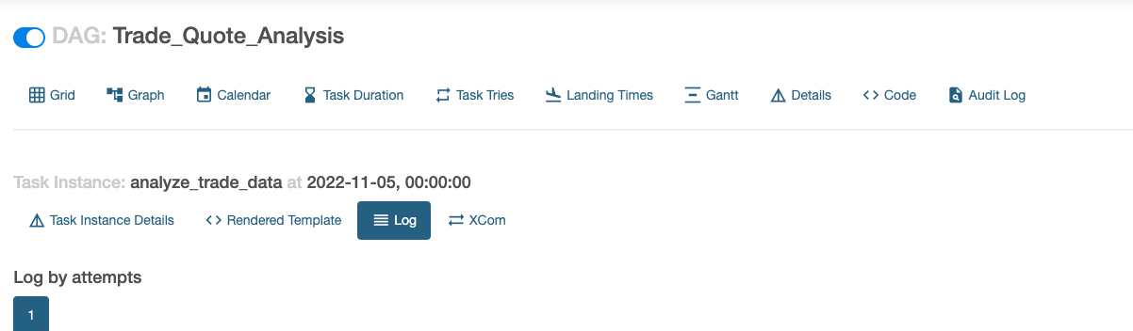

*** Reading remote log from gs://us-east1-spark-airflow-comp-9c560139-bucket/logs/dag_id=Trade_Quote_Analysis/run_id=scheduled__2022-11-05T00:00:00+00:00/task_id=analyze_trade_data/attempt=1.log.

[2022-11-06, 04:01:05 UTC] {taskinstance.py:1180} INFO - Dependencies all met for <TaskInstance: Trade_Quote_Analysis.analyze_trade_data scheduled__2022-11-05T00:00:00+00:00 [queued]>

[2022-11-06, 04:01:06 UTC] {taskinstance.py:1180} INFO - Dependencies all met for <TaskInstance: Trade_Quote_Analysis.analyze_trade_data scheduled__2022-11-05T00:00:00+00:00 [queued]>

[2022-11-06, 04:01:06 UTC] {taskinstance.py:1377} INFO -

--------------------------------------------------------------------------------

[2022-11-06, 04:01:06 UTC] {taskinstance.py:1378} INFO - Starting attempt 1 of 3

[2022-11-06, 04:01:06 UTC] {taskinstance.py:1379} INFO -

--------------------------------------------------------------------------------

[2022-11-06, 04:01:06 UTC] {taskinstance.py:1398} INFO - Executing <Task(DataprocCreateBatchOperator): analyze_trade_data> on 2022-11-05 00:00:00+00:00

[2022-11-06, 04:01:06 UTC] {standard_task_runner.py:52} INFO - Started process 2313 to run task

[2022-11-06, 04:01:06 UTC] {standard_task_runner.py:79} INFO - Running: ['airflow', 'tasks', 'run', 'Trade_Quote_Analysis', 'analyze_trade_data', 'scheduled__2022-11-05T00:00:00+00:00', '--job-id', '53', '--raw', '--subdir', 'DAGS_FOLDER/trade_analysis_pipeline.py', '--cfg-path', '/tmp/tmpvb06du22', '--error-file', '/tmp/tmpe63o4qyl']

[2022-11-06, 04:01:06 UTC] {standard_task_runner.py:80} INFO - Job 53: Subtask analyze_trade_data

[2022-11-06, 04:01:06 UTC] {task_command.py:375} INFO - Running <TaskInstance: Trade_Quote_Analysis.analyze_trade_data scheduled__2022-11-05T00:00:00+00:00 [running]> on host airflow-worker-trp9b

[2022-11-06, 04:01:07 UTC] {taskinstance.py:1591} INFO - Exporting the following env vars:

AIRFLOW_CTX_DAG_OWNER=airflow

AIRFLOW_CTX_DAG_ID=Trade_Quote_Analysis

AIRFLOW_CTX_TASK_ID=analyze_trade_data

AIRFLOW_CTX_EXECUTION_DATE=2022-11-05T00:00:00+00:00

AIRFLOW_CTX_TRY_NUMBER=1

AIRFLOW_CTX_DAG_RUN_ID=scheduled__2022-11-05T00:00:00+00:00

[2022-11-06, 04:01:07 UTC] {base.py:68} INFO - Using connection ID 'google_cloud_default' for task execution.

[2022-11-06, 04:01:07 UTC] {dataproc.py:2022} INFO - Creating batch

[2022-11-06, 04:01:37 UTC] {local_task_job.py:220} WARNING - State of this instance has been externally set to None. Terminating instance.

[2022-11-06, 04:01:37 UTC] {process_utils.py:125} INFO - Sending Signals.SIGTERM to group 2313. PIDs of all processes in the group: [2313]

[2022-11-06, 04:01:37 UTC] {process_utils.py:80} INFO - Sending the signal Signals.SIGTERM to group 2313

[2022-11-06, 04:01:37 UTC] {taskinstance.py:1563} ERROR - Received SIGTERM. Terminating subprocesses.

[2022-11-06, 04:03:43 UTC] {taskinstance.py:1911} ERROR - Task failed with exception

Traceback (most recent call last):

File "/opt/python3.8/lib/python3.8/site-packages/airflow/providers/google/cloud/hooks/dataproc.py", line 246, in wait_for_operation

return operation.result(timeout=timeout)

File "/opt/python3.8/lib/python3.8/site-packages/google/api_core/future/polling.py", line 132, in result

self._blocking_poll(timeout=timeout, **kwargs)

File "/opt/python3.8/lib/python3.8/site-packages/google/api_core/future/polling.py", line 110, in _blocking_poll

retry_(self._done_or_raise)(**kwargs)

File "/opt/python3.8/lib/python3.8/site-packages/google/api_core/retry.py", line 283, in retry_wrapped_func

return retry_target(

File "/opt/python3.8/lib/python3.8/site-packages/google/api_core/retry.py", line 218, in retry_target

time.sleep(sleep)

File "/opt/python3.8/lib/python3.8/site-packages/airflow/models/taskinstance.py", line 1565, in signal_handler

raise AirflowException("Task received SIGTERM signal")

airflow.exceptions.AirflowException: Task received SIGTERM signal

During handling of the above exception, another exception occurred:

Traceback (most recent call last):

File "/opt/python3.8/lib/python3.8/site-packages/airflow/providers/google/cloud/operators/dataproc.py", line 2038, in execute

result = hook.wait_for_operation(timeout=self.timeout, operation=self.operation)

File "/opt/python3.8/lib/python3.8/site-packages/airflow/providers/google/cloud/hooks/dataproc.py", line 249, in wait_for_operation

raise AirflowException(error)

airflow.exceptions.AirflowException: None

[2022-11-06, 04:03:43 UTC] {taskinstance.py:1416} INFO - Marking task as UP_FOR_RETRY. dag_id=Trade_Quote_Analysis, task_id=analyze_trade_data, execution_date=20221105T000000, start_date=, end_date=20221106T040343

[2022-11-06, 04:03:43 UTC] {standard_task_runner.py:92} ERROR - Failed to execute job 53 for task analyze_trade_data ((psycopg2.errors.UniqueViolation) duplicate key value violates unique constraint "dag_run_dag_id_run_id_key"

DETAIL: Key (dag_id, run_id)=(Trade_Quote_Analysis, scheduled__2022-11-05T00:00:00+00:00) already exists.

[SQL: INSERT INTO dag_run (id, dag_id, queued_at, execution_date, start_date, end_date, state, run_id, creating_job_id, external_trigger, run_type, conf, data_interval_start, data_interval_end, last_scheduling_decision, dag_hash, log_template_id) VALUES (%(id)s, %(dag_id)s, %(queued_at)s, %(execution_date)s, %(start_date)s, %(end_date)s, %(state)s, %(run_id)s, %(creating_job_id)s, %(external_trigger)s, %(run_type)s, %(conf)s, %(data_interval_start)s, %(data_interval_end)s, %(last_scheduling_decision)s, %(dag_hash)s, %(log_template_id)s)]

[parameters: {'id': 31, 'dag_id': 'Trade_Quote_Analysis', 'queued_at': datetime.datetime(2022, 11, 6, 4, 0, 58, 24416, tzinfo=Timezone('UTC')), 'execution_date': datetime.datetime(2022, 11, 5, 0, 0, tzinfo=Timezone('UTC')), 'start_date': datetime.datetime(2022, 11, 6, 4, 0, 58, 69679, tzinfo=Timezone('UTC')), 'end_date': None, 'state': 'running', 'run_id': 'scheduled__2022-11-05T00:00:00+00:00', 'creating_job_id': 48, 'external_trigger': False, 'run_type': 'scheduled', 'conf': <psycopg2.extensions.Binary object at 0x7f85aa34d150>, 'data_interval_start': datetime.datetime(2022, 11, 5, 0, 0, tzinfo=Timezone('UTC')), 'data_interval_end': datetime.datetime(2022, 11, 6, 0, 0, tzinfo=Timezone('UTC')), 'last_scheduling_decision': datetime.datetime(2022, 11, 6, 4, 1, 3, 514930, tzinfo=Timezone('UTC')), 'dag_hash': '825759430eed0eba5fbd23bf78b588af', 'log_template_id': 2}]

(Background on this error at: <https://sqlalche.me/e/14/gkpj);> 2313)

[2022-11-06, 04:03:43 UTC] {process_utils.py:75} INFO - Process psutil.Process(pid=2313, status='terminated', exitcode=1, started='04:01:05') (2313) terminated with exit code 1

[2022-11-06, 04:09:33 UTC] {taskinstance.py:1180} INFO - Dependencies all met for <TaskInstance: Trade_Quote_Analysis.analyze_trade_data scheduled__2022-11-05T00:00:00+00:00 [queued]>

[2022-11-06, 04:09:33 UTC] {taskinstance.py:1180} INFO - Dependencies all met for <TaskInstance: Trade_Quote_Analysis.analyze_trade_data scheduled__2022-11-05T00:00:00+00:00 [queued]>

[2022-11-06, 04:09:33 UTC] {taskinstance.py:1377} INFO -

--------------------------------------------------------------------------------

[2022-11-06, 04:09:33 UTC] {taskinstance.py:1378} INFO - Starting attempt 1 of 3

[2022-11-06, 04:09:33 UTC] {taskinstance.py:1379} INFO -

--------------------------------------------------------------------------------

[2022-11-06, 04:09:33 UTC] {taskinstance.py:1398} INFO - Executing <Task(DataprocCreateBatchOperator): analyze_trade_data> on 2022-11-05 00:00:00+00:00

[2022-11-06, 04:09:33 UTC] {standard_task_runner.py:52} INFO - Started process 2551 to run task

[2022-11-06, 04:09:33 UTC] {standard_task_runner.py:79} INFO - Running: ['airflow', 'tasks', 'run', 'Trade_Quote_Analysis', 'analyze_trade_data', 'scheduled__2022-11-05T00:00:00+00:00', '--job-id', '59', '--raw', '--subdir', 'DAGS_FOLDER/trade_analysis_pipeline.py', '--cfg-path', '/tmp/tmpdy_313iq', '--error-file', '/tmp/tmpx7wbt5ab']

[2022-11-06, 04:09:33 UTC] {standard_task_runner.py:80} INFO - Job 59: Subtask analyze_trade_data

[2022-11-06, 04:09:33 UTC] {task_command.py:375} INFO - Running <TaskInstance: Trade_Quote_Analysis.analyze_trade_data scheduled__2022-11-05T00:00:00+00:00 [running]> on host airflow-worker-trp9b

[2022-11-06, 04:09:34 UTC] {taskinstance.py:1591} INFO - Exporting the following env vars:

AIRFLOW_CTX_DAG_OWNER=airflow

AIRFLOW_CTX_DAG_ID=Trade_Quote_Analysis

AIRFLOW_CTX_TASK_ID=analyze_trade_data

AIRFLOW_CTX_EXECUTION_DATE=2022-11-05T00:00:00+00:00

AIRFLOW_CTX_TRY_NUMBER=1

AIRFLOW_CTX_DAG_RUN_ID=scheduled__2022-11-05T00:00:00+00:00

[2022-11-06, 04:09:34 UTC] {base.py:68} INFO - Using connection ID 'google_cloud_default' for task execution.

[2022-11-06, 04:09:34 UTC] {dataproc.py:2022} INFO - Creating batch

[2022-11-06, 04:14:02 UTC] {dataproc.py:2039} INFO - Batch process-batch-create created

[2022-11-06, 04:14:02 UTC] {taskinstance.py:1416} INFO - Marking task as SUCCESS. dag_id=Trade_Quote_Analysis, task_id=analyze_trade_data, execution_date=20221105T000000, start_date=20221106T040933, end_date=20221106T041402

[2022-11-06, 04:14:03 UTC] {local_task_job.py:156} INFO - Task exited with return code 0

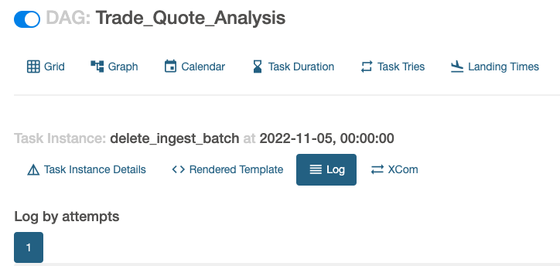

*** Reading remote log from gs://us-east1-spark-airflow-comp-9c560139-bucket/logs/dag_id=Trade_Quote_Analysis/run_id=scheduled__2022-11-05T00:00:00+00:00/task_id=delete_ingest_batch/attempt=1.log.

[2022-11-06, 04:14:08 UTC] {taskinstance.py:1180} INFO - Dependencies all met for <TaskInstance: Trade_Quote_Analysis.delete_ingest_batch scheduled__2022-11-05T00:00:00+00:00 [queued]>

[2022-11-06, 04:14:08 UTC] {taskinstance.py:1180} INFO - Dependencies all met for <TaskInstance: Trade_Quote_Analysis.delete_ingest_batch scheduled__2022-11-05T00:00:00+00:00 [queued]>

[2022-11-06, 04:14:08 UTC] {taskinstance.py:1377} INFO -

--------------------------------------------------------------------------------

[2022-11-06, 04:14:08 UTC] {taskinstance.py:1378} INFO - Starting attempt 1 of 3

[2022-11-06, 04:14:08 UTC] {taskinstance.py:1379} INFO -

--------------------------------------------------------------------------------

[2022-11-06, 04:14:08 UTC] {taskinstance.py:1398} INFO - Executing <Task(DataprocDeleteBatchOperator): delete_ingest_batch> on 2022-11-05 00:00:00+00:00

[2022-11-06, 04:14:08 UTC] {standard_task_runner.py:52} INFO - Started process 2670 to run task

[2022-11-06, 04:14:08 UTC] {standard_task_runner.py:79} INFO - Running: ['airflow', 'tasks', 'run', 'Trade_Quote_Analysis', 'delete_ingest_batch', 'scheduled__2022-11-05T00:00:00+00:00', '--job-id', '61', '--raw', '--subdir', 'DAGS_FOLDER/trade_analysis_pipeline.py', '--cfg-path', '/tmp/tmps7fn7q6v', '--error-file', '/tmp/tmp81jnj592']

[2022-11-06, 04:14:08 UTC] {standard_task_runner.py:80} INFO - Job 61: Subtask delete_ingest_batch

[2022-11-06, 04:14:09 UTC] {task_command.py:375} INFO - Running <TaskInstance: Trade_Quote_Analysis.delete_ingest_batch scheduled__2022-11-05T00:00:00+00:00 [running]> on host airflow-worker-trp9b

[2022-11-06, 04:14:10 UTC] {taskinstance.py:1591} INFO - Exporting the following env vars:

AIRFLOW_CTX_DAG_OWNER=airflow

AIRFLOW_CTX_DAG_ID=Trade_Quote_Analysis

AIRFLOW_CTX_TASK_ID=delete_ingest_batch

AIRFLOW_CTX_EXECUTION_DATE=2022-11-05T00:00:00+00:00

AIRFLOW_CTX_TRY_NUMBER=1

AIRFLOW_CTX_DAG_RUN_ID=scheduled__2022-11-05T00:00:00+00:00

[2022-11-06, 04:14:10 UTC] {base.py:68} INFO - Using connection ID 'google_cloud_default' for task execution.

[2022-11-06, 04:14:10 UTC] {dataproc.py:2113} INFO - Deleting batch: ingest-batch-create

[2022-11-06, 04:14:10 UTC] {dataproc.py:2122} INFO - Batch deleted.

[2022-11-06, 04:14:10 UTC] {taskinstance.py:1416} INFO - Marking task as SUCCESS. dag_id=Trade_Quote_Analysis, task_id=delete_ingest_batch, execution_date=20221105T000000, start_date=20221106T041408, end_date=20221106T041410

[2022-11-06, 04:14:10 UTC] {local_task_job.py:156} INFO - Task exited with return code 0

[2022-11-06, 04:14:10 UTC] {local_task_job.py:273} INFO - 0 downstream tasks scheduled from follow-on schedule check

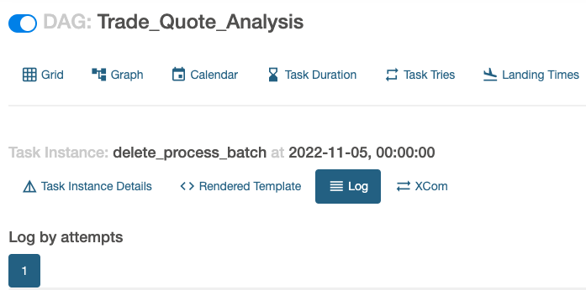

*** Reading remote log from gs://us-east1-spark-airflow-comp-9c560139-bucket/logs/dag_id=Trade_Quote_Analysis/run_id=scheduled__2022-11-05T00:00:00+00:00/task_id=delete_process_batch/attempt=1.log.

[2022-11-06, 04:14:08 UTC] {taskinstance.py:1180} INFO - Dependencies all met for <TaskInstance: Trade_Quote_Analysis.delete_process_batch scheduled__2022-11-05T00:00:00+00:00 [queued]>

[2022-11-06, 04:14:08 UTC] {taskinstance.py:1180} INFO - Dependencies all met for <TaskInstance: Trade_Quote_Analysis.delete_process_batch scheduled__2022-11-05T00:00:00+00:00 [queued]>

[2022-11-06, 04:14:08 UTC] {taskinstance.py:1377} INFO -

--------------------------------------------------------------------------------

[2022-11-06, 04:14:08 UTC] {taskinstance.py:1378} INFO - Starting attempt 1 of 3

[2022-11-06, 04:14:08 UTC] {taskinstance.py:1379} INFO -

--------------------------------------------------------------------------------

[2022-11-06, 04:14:08 UTC] {taskinstance.py:1398} INFO - Executing <Task(DataprocDeleteBatchOperator): delete_process_batch> on 2022-11-05 00:00:00+00:00

[2022-11-06, 04:14:08 UTC] {standard_task_runner.py:52} INFO - Started process 2669 to run task

[2022-11-06, 04:14:08 UTC] {standard_task_runner.py:79} INFO - Running: ['airflow', 'tasks', 'run', 'Trade_Quote_Analysis', 'delete_process_batch', 'scheduled__2022-11-05T00:00:00+00:00', '--job-id', '60', '--raw', '--subdir', 'DAGS_FOLDER/trade_analysis_pipeline.py', '--cfg-path', '/tmp/tmpkw17wvlz', '--error-file', '/tmp/tmpv8z6nhmn']

[2022-11-06, 04:14:08 UTC] {standard_task_runner.py:80} INFO - Job 60: Subtask delete_process_batch

[2022-11-06, 04:14:09 UTC] {task_command.py:375} INFO - Running <TaskInstance: Trade_Quote_Analysis.delete_process_batch scheduled__2022-11-05T00:00:00+00:00 [running]> on host airflow-worker-trp9b

[2022-11-06, 04:14:09 UTC] {taskinstance.py:1591} INFO - Exporting the following env vars:

AIRFLOW_CTX_DAG_OWNER=airflow

AIRFLOW_CTX_DAG_ID=Trade_Quote_Analysis

AIRFLOW_CTX_TASK_ID=delete_process_batch

AIRFLOW_CTX_EXECUTION_DATE=2022-11-05T00:00:00+00:00

AIRFLOW_CTX_TRY_NUMBER=1

AIRFLOW_CTX_DAG_RUN_ID=scheduled__2022-11-05T00:00:00+00:00

[2022-11-06, 04:14:09 UTC] {base.py:68} INFO - Using connection ID 'google_cloud_default' for task execution.

[2022-11-06, 04:14:09 UTC] {dataproc.py:2113} INFO - Deleting batch: process-batch-create

[2022-11-06, 04:14:10 UTC] {dataproc.py:2122} INFO - Batch deleted.

[2022-11-06, 04:14:10 UTC] {taskinstance.py:1416} INFO - Marking task as SUCCESS. dag_id=Trade_Quote_Analysis, task_id=delete_process_batch, execution_date=20221105T000000, start_date=20221106T041408, end_date=20221106T041410

[2022-11-06, 04:14:10 UTC] {local_task_job.py:156} INFO - Task exited with return code 0

[2022-11-06, 04:14:10 UTC] {local_task_job.py:273} INFO - 0 downstream tasks scheduled from follow-on schedule check

Data written by Spark in Cloud:

